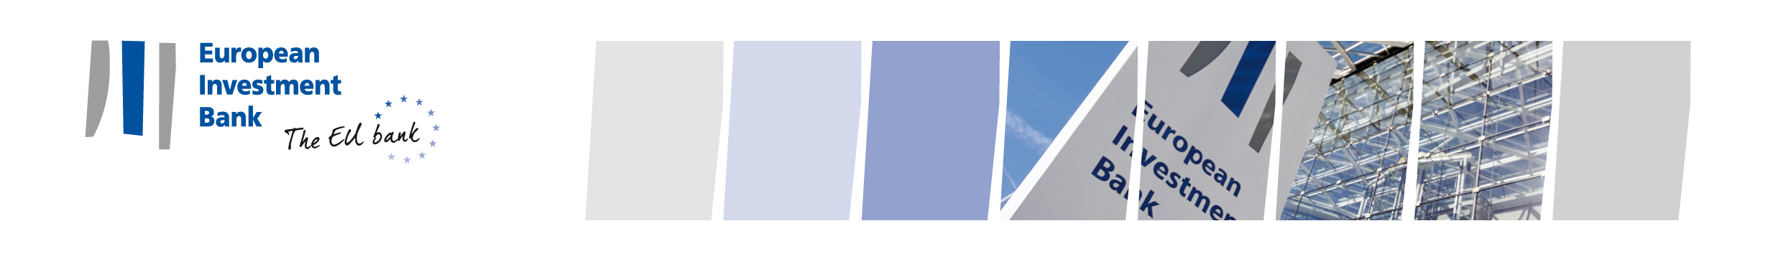

**Curriculum Vitae**

|  |  |
| --- | --- |
| no_photo_m.jpeg | **Nina MARIN** Director of the EIB |

*Personal Information:*

* Slovene

*Career:*

* **August 2022 - present**
  + Legal expert at Pravno svetovanje Nina Marin s.p.
* **May 2022 - August 2022**
* President of the Management Board of Istrabenz Turizem d.d.

Portorose, Slovenia

* **April 2022 - August 2022**
* Member of Supervisory Board in Mladinska knjiga založba d.d.

Ljubljana, Slovenia

* **1 April – 12 May 2022**
* Member of the Management Board of Istrabenz Turizem d.d. and under the authority of Supervisory Board the President of the Management Board

Portorose, Slovenia

* **Since 17 November 2020 - present**
  + Member of Supervisory Board in ZGP d.d., Zeleznisko gradbeno podjetje d.d.

Ljubljana, Slovenia

* **10 November 2020 – April 2022**
* Alternate Governor for Slovenia at European Bank for Reconstruction and Development (EBRD)

London, United Kingdom

* **10 May 2020 – 31 March 2022**
* Acting Head of Service for Legislation at Ministry of Finance

Ljubljana, Slovenia

* **15 April 2020 – 31 March 2022**
* Head of the Project group for Slovenian Presidency of the Council of EU

Ministry of Finance, Slovenia

* **16 March 2020 – 31 March 2022**
* Secretary at Minister's Office, Ministry of Finance

Ljubljana, Slovenia

* **1 March 2018 - 13 March 2020**
* Attorney Trainee at Lawyer Franci Matoz nad Law Firm Matoz

Koper, Slovenia

*Education:*

* **Since 1 October 2018**
* Doctor of Law at Faculty of Law, University of Maribor

Maribor, Slovenia

* **1 February 2017 - 30 April 2017**
* Research Student at Faculty of Law, University of Cambridge

Cambridge, United Kingdom

* **1 October 2016 - 28 June 2018**
* Master in Law at Faculty of Law, University of Maribor

Maribor, Slovenia

* **1 September 2014 - 30 June 2015**
* Erasmus & Student at Faculty of Law, Kingston University London

London, United Kingdom

* **1 October 2011 - 30 September 2016**
* Law Graduate at Faculty of Law, University of Maribor

Maribor, Slovenia

*Other:*

* Language skills: Slovenian (native), English (fluent), German, Croatian and Italian (moderate)